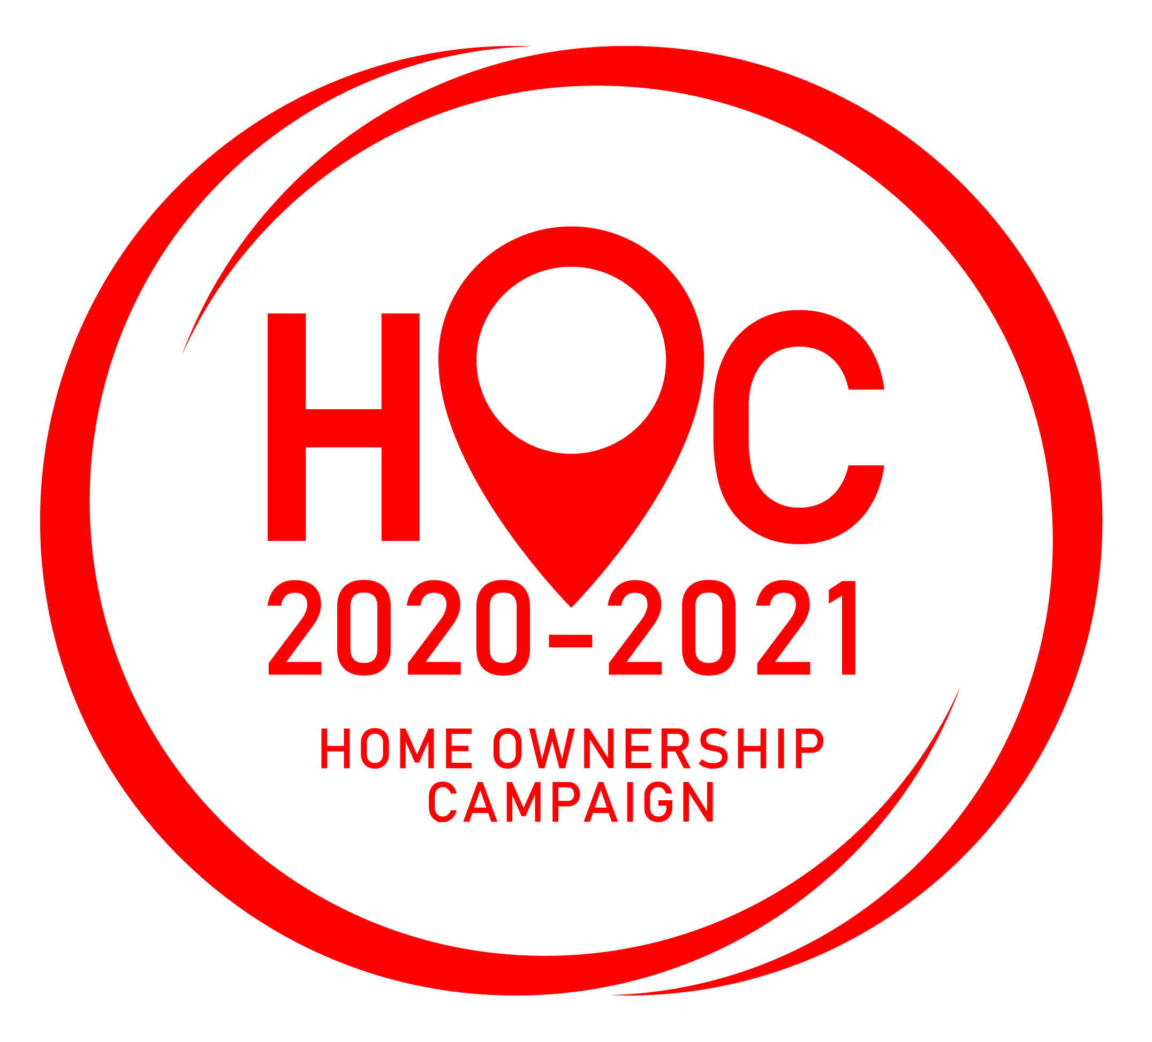
FORM A

HOME OWNERSHIP CAMPAIGN 2020-2021

STAMP DUTY WAIVER FOR PURCHASE OF RESIDENTIAL PROPERTIES
1 JUNE 2020 – 31 MAY 2021

REGISTRATION FORM

 | *NEW REGISTRATION |  |  | *RE-REGISTRATION

(Please fill up separate forms for each application. Completed forms must be submitted to Sabah Housing And Real Estate Developers Association at Lot 1-3(F), 3rd Floor, Beverly Hills Plaza, Jalan Bundusan, 88300 Kota Kinabalu, Sabah and emailed to hoc2020@shareda.com. All registration forms must be accompanied by the requisite fee (bank deposit slip) for Registration with certified true copies by a Solicitor of valid Developer’s Licence and Advertisement and Sale Permit (APDL) and/or Occupation Certificate (OC).

NAME OF DEVELOPER : _________________________________________________________________

CO. NO : _______________________ MEMBERSHIP NO: SHAREDA/____________________________

(if applicable)

ADDRESS : ________________________________________________________________________

________________________________________________________________________

POSTCODE : ____________________ CITY: _________________________________ STATE: SABAH

TEL NO : ____________________________________ FAX NO: __________________________

EMAIL : ________________________________________________________________________

CONTACT PERSON: ____________________________________________________________________

DESIGNATION : ____________________________________ H/P : _____________________________

REGISTRATION OF PROJECT: *PER UNIT [ ___________ ] or *PER PROJECT [ _______________ ]

RM

*PAYMENT REF. / *CHEQUE NO: ____________________________ AMOUNT : _________________

DATE : ____________________

All fees shall be made payable to “SABAH HOUSING AND REAL ESTATE DEVELOPERS ASSOCIATION”, Bank Deposit: Account no. 510107460022 at Malayan Banking Berhad, Jalan Perpaduan, Kota Kinabalu, Sabah. Proof of payment (bank deposit slip) must be submitted/attached and emailed to hoc2020@shareda.com.

FOR OFFICE USE ONLY

REGISTRATION NO : _________________________ DATE: _________________________

INVOICE NO : SHAREDA/ _______________ DATE: _________________________

RECEIPT NO : OR- _____________________ DATE: _________________________

REMARKS : ______________________________________________________________

______________________________________________________________

