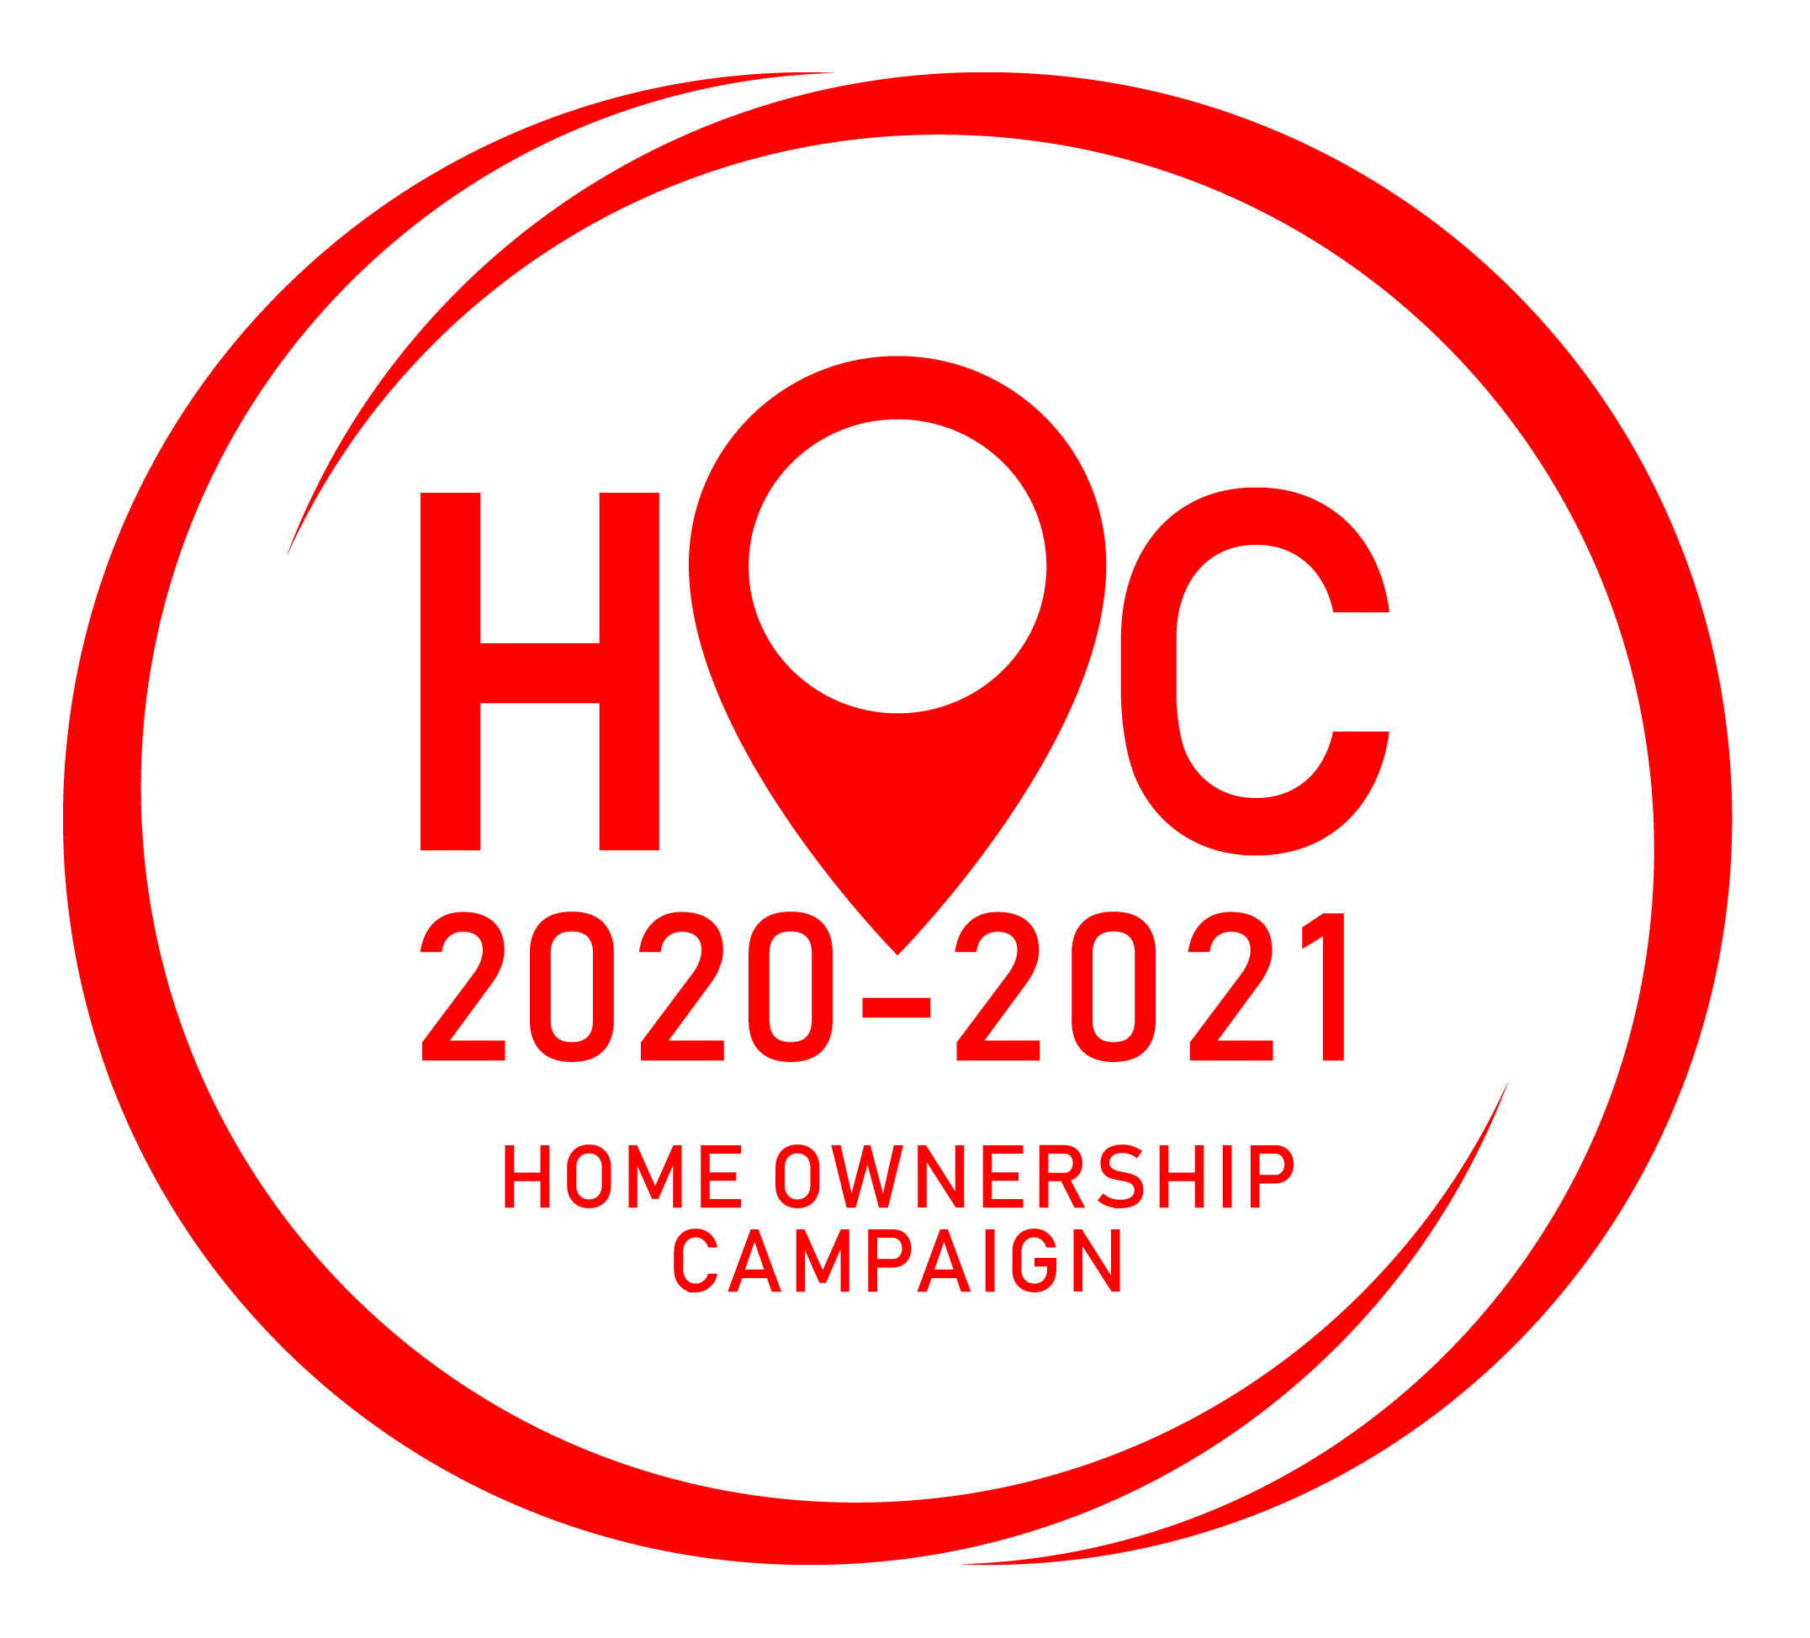
FORM B1

HOME OWNERSHIP CAMPAIGN 2020-2021

STAMP DUTY WAIVER FOR PURCHASE OF RESIDENTIAL PROPERTIES
1 JUNE 2020 – 31 MAY 2021

DETAILS OF PROJECT

NAME OF DEVELOPER : __________________________________________________________________________

NAME OF PROJECT : __________________________________________________________________________

LOT NO. : ________________________ MASTER TITLE: ____________________________________

MUKIM : ________________________ LOCATION: ________________________________________

STATE : SABAH DISTRICT: _________________________________________________________________

DEVELOPER’S LICENCE NO: _______________________________________________________________________

ADVERTISMENT PERMIT NO: _______________________________________________________________________

TOTAL UNITS REGISTERED: _______________________ TOTAL VALUE: RM _______________________________

*UC : UNDER CONSTRUCTION

OR

*OC : COMPLETED WITH OC

I HEREBY DECLARE THAT ALL INFORMATION SUBMITTED FOR THE ABOVE PROJECT AND ATTACHED PROPERTY LISTING (FORM B2 – Excel) ARE TRUE AND ACCURATE, AND THAT I AM AUTHORISED ON BEHALF OF THE COMPANY TO MAKE THIS DECLARATION.

Signature: | Company Stamp:

Name:

Position:

Company:

Date:

Note: Signatory to be in a managerial position or higher.

Attached: Form B2 in Excel.

